* Using Packet Tracer, create a wireless network of multiple PCs using appropriate access point.
* Add wireless router-WRT300N and 3PC :-

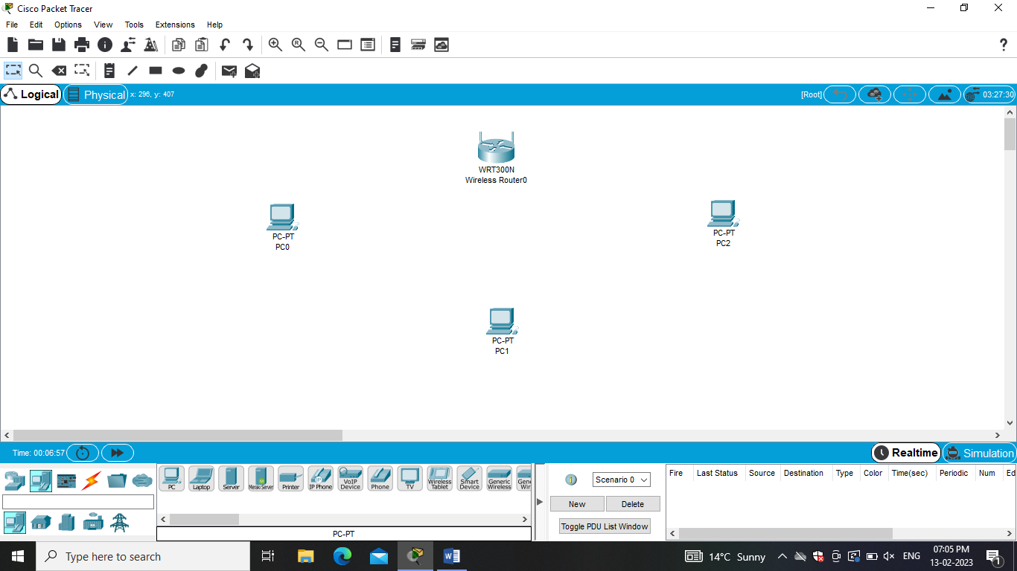

* Router- DHCP Server Setting - Disable and Save Setting :-

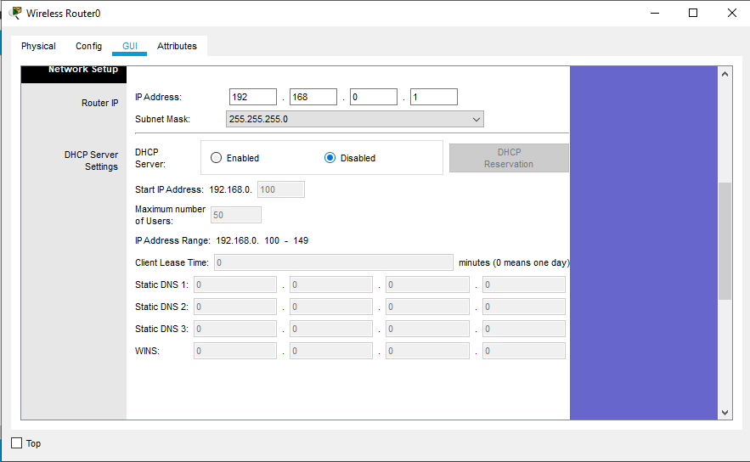

* Wireless – Network Name:Mynetwork and Save Setting :-

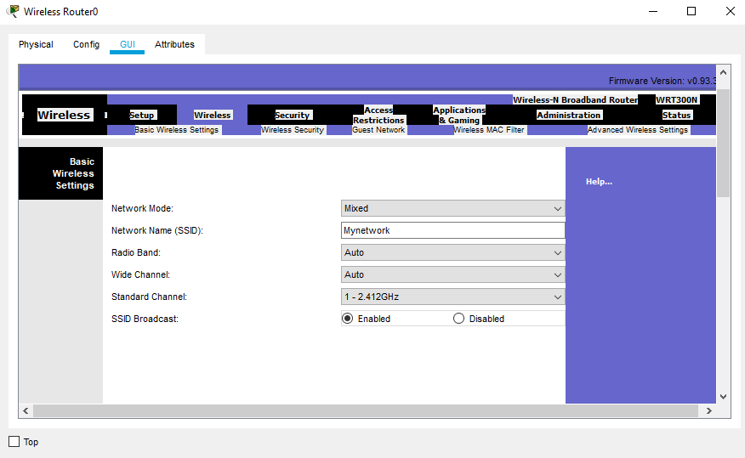

* Wireless Security-Security mode:WEP ,Key1:0123456789 and Save Setting:-

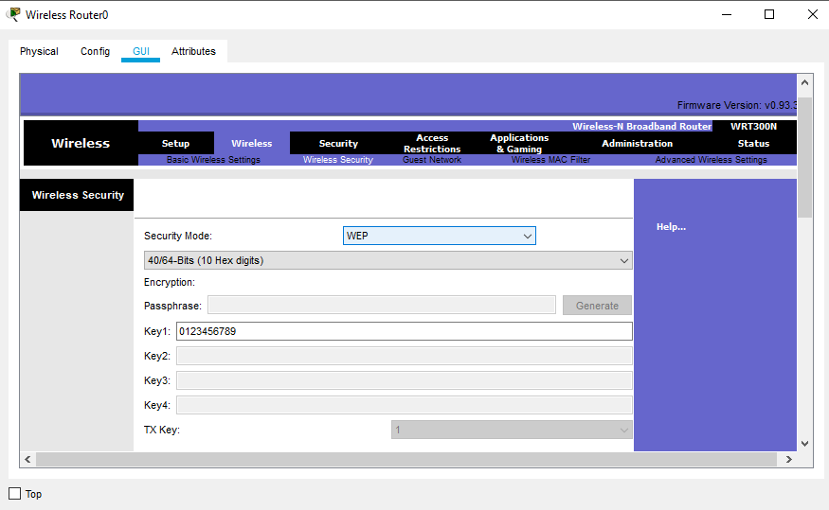

* For all PC – Remove Port and Add WMP300N and on

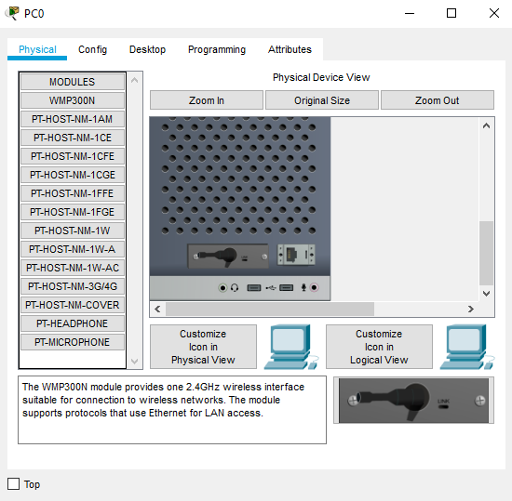

* PC0 Static IP – 192.168.0.6 and Default gateway – 192.168.0.1 :-

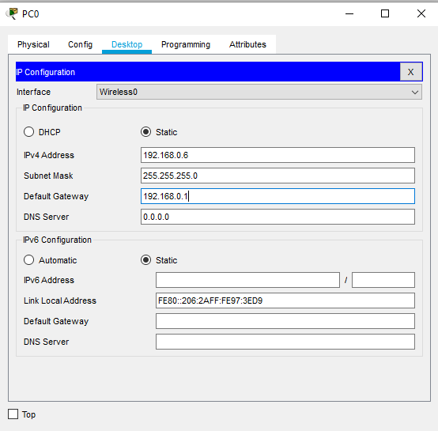

* PC1 Static IP – 192.168.0.7 and Default gateway – 192.168.0.1 :-

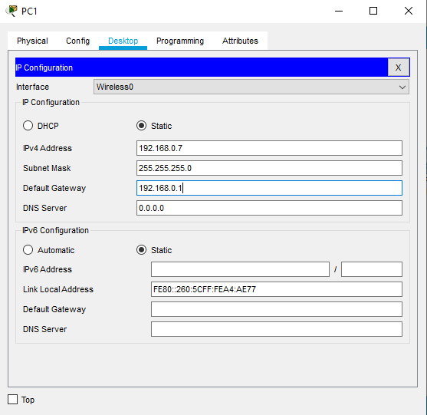

* PC2 Static IP – 192.168.0.8 and Default gateway – 192.168.0.1 :-

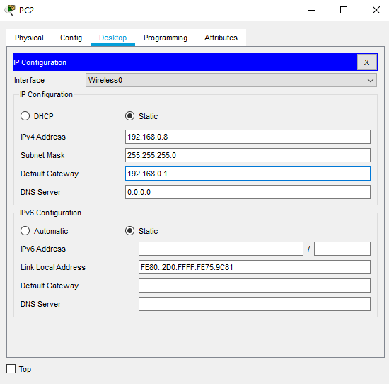

* For all PC:-

1. Desktop-pcwireless-connect :-

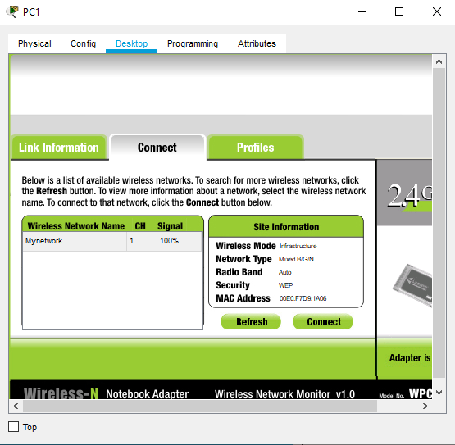

1. Add WEP key1-0123456789 :-

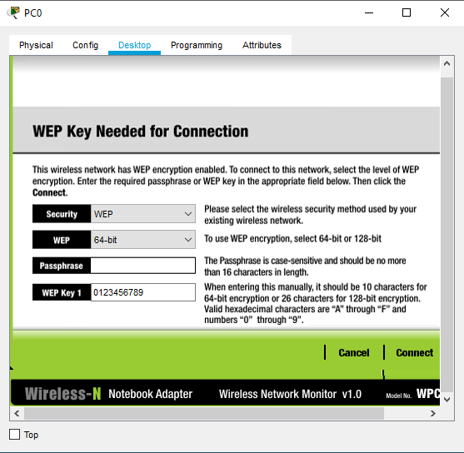

3.Successfully connected :-

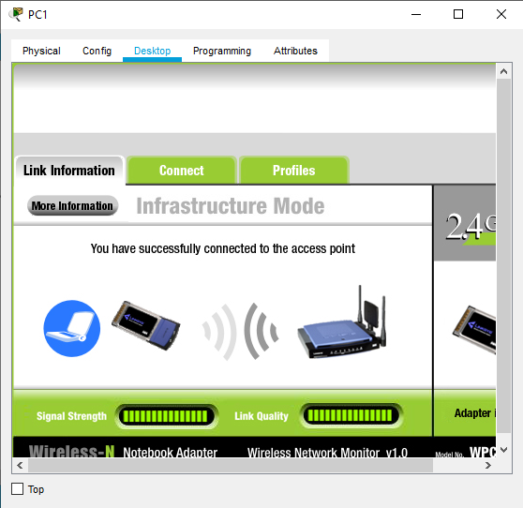

* Open Command Prompt and use ping command :-

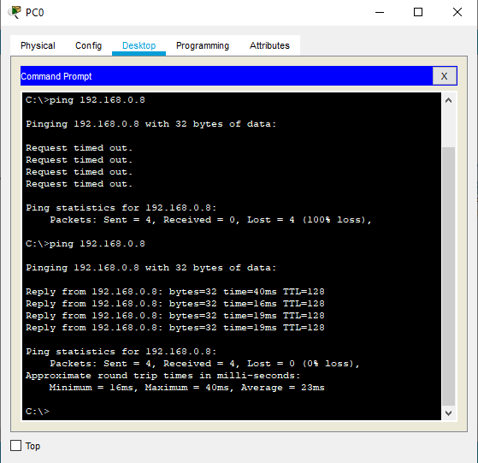

* Realtime :-

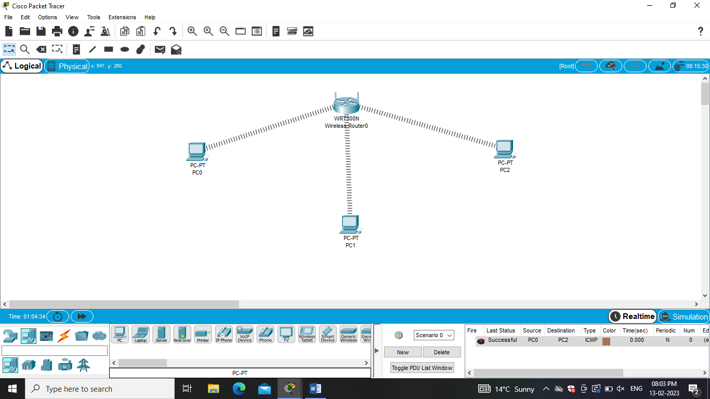

* Semulation :-

